AWS EC2: adding a volume and creating a text file

PART 1: Launching an Amazon EC2 Instance

Step 1: Open the EC2 Dashboard
Log in to the AWS Management Console and navigate to the EC2 service. The EC2 Dashboard shows all current resources in the selected region .
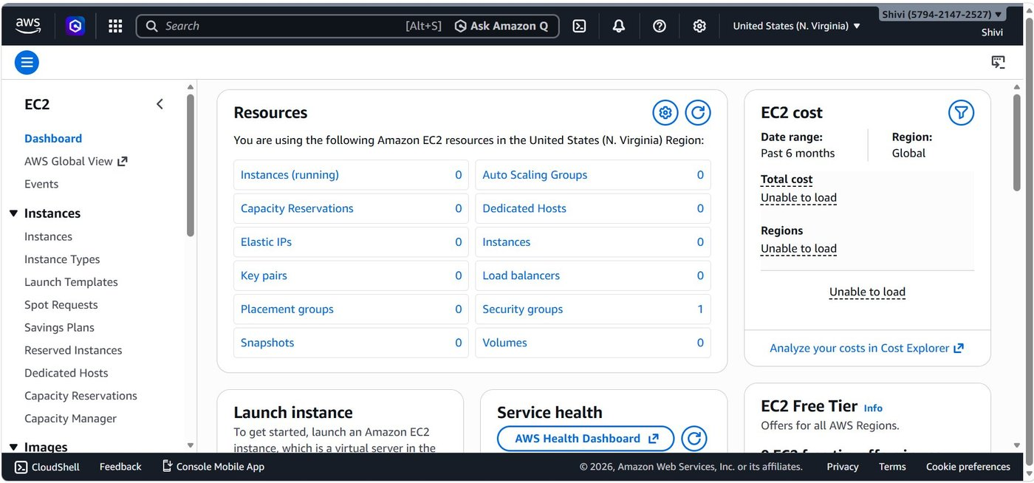

Step 2: Name Your Instance & Choose an AMI
On the "Launch an instance" page, enter a name and select an Amazon Machine Image (AMI).
- Name and tags → Enter a name (e.g., shivi_2026).
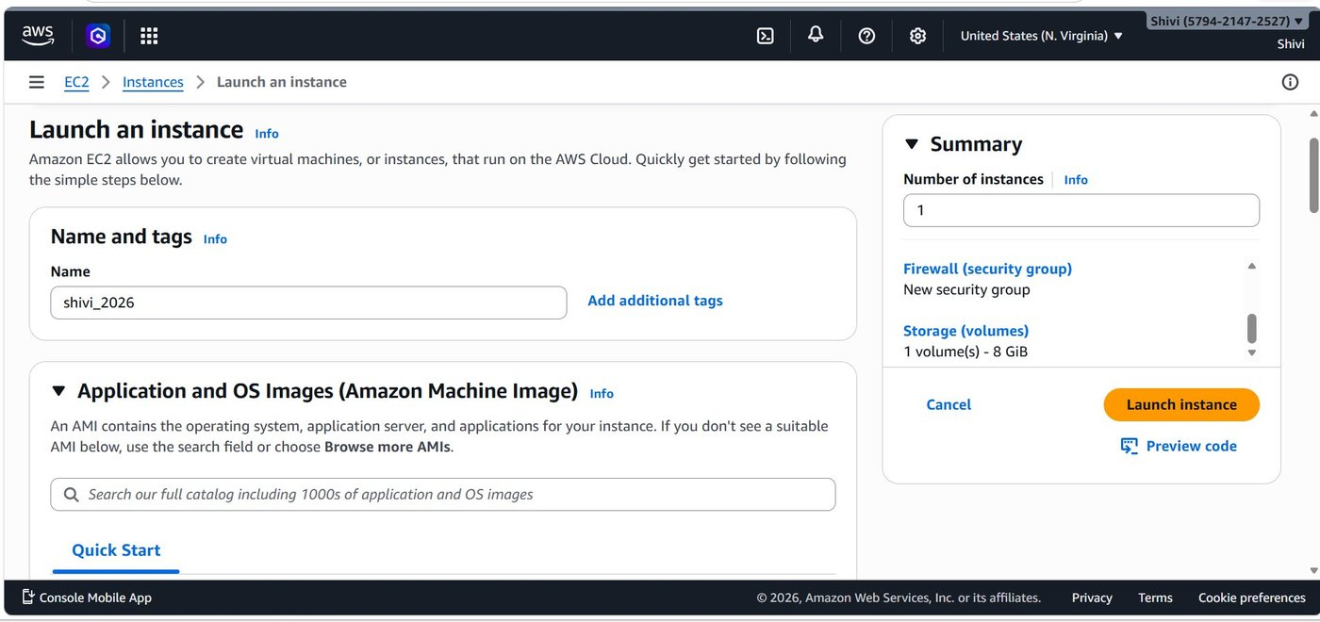

Step 3: Select Instance Type
Choose the hardware configuration for your instance.
- Default: t3.micro — Free tier eligible, 2 vCPU, 1 GiB Memory, current generation.
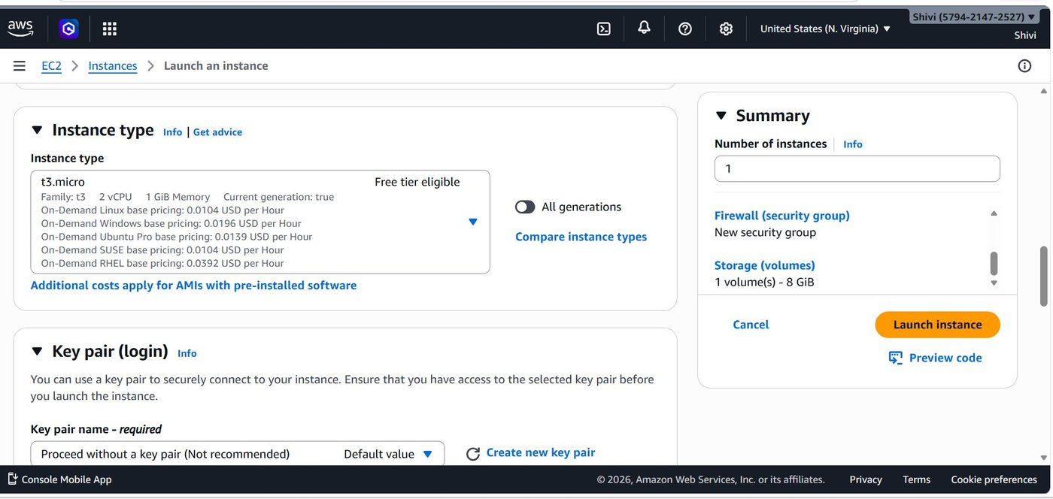

Step 4: Configure Key Pair (Login)
A key pair enables secure SSH access to your instance.
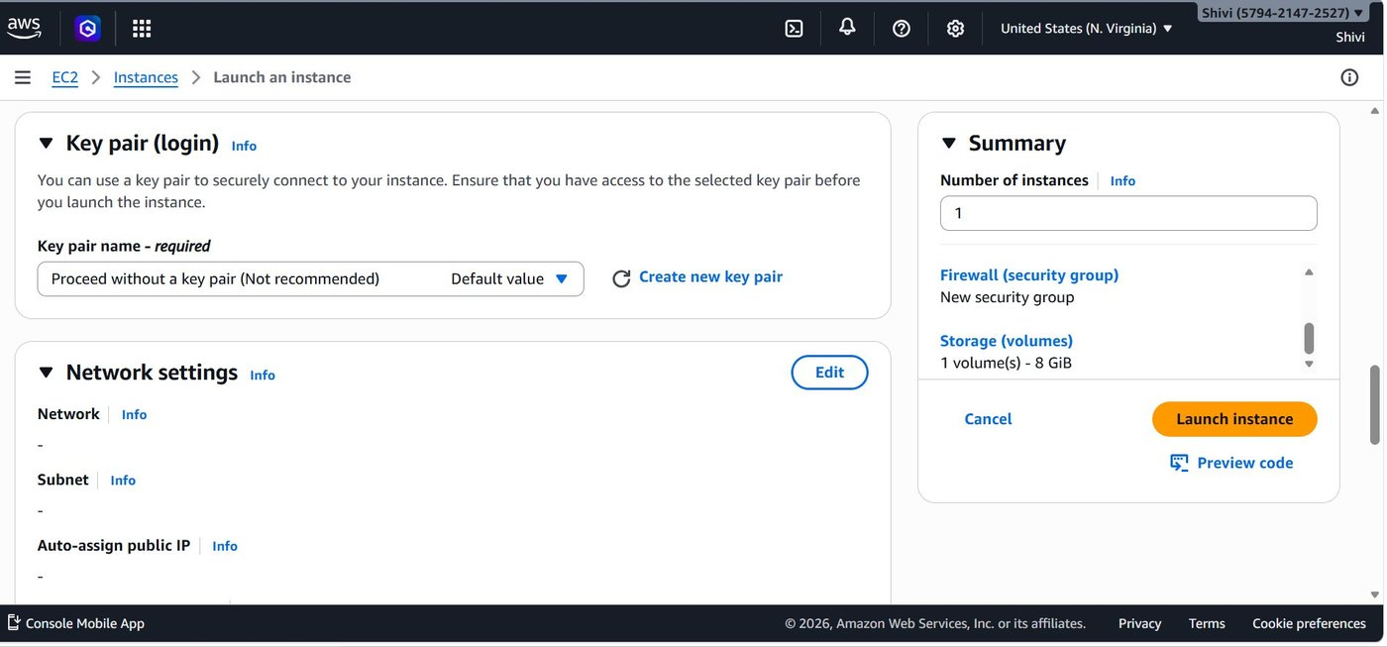

Step 5: Configure Firewall (Security Group)
A Security Group acts as a virtual firewall. AWS auto-creates one named launch-wizard-1 with three inbound rules.
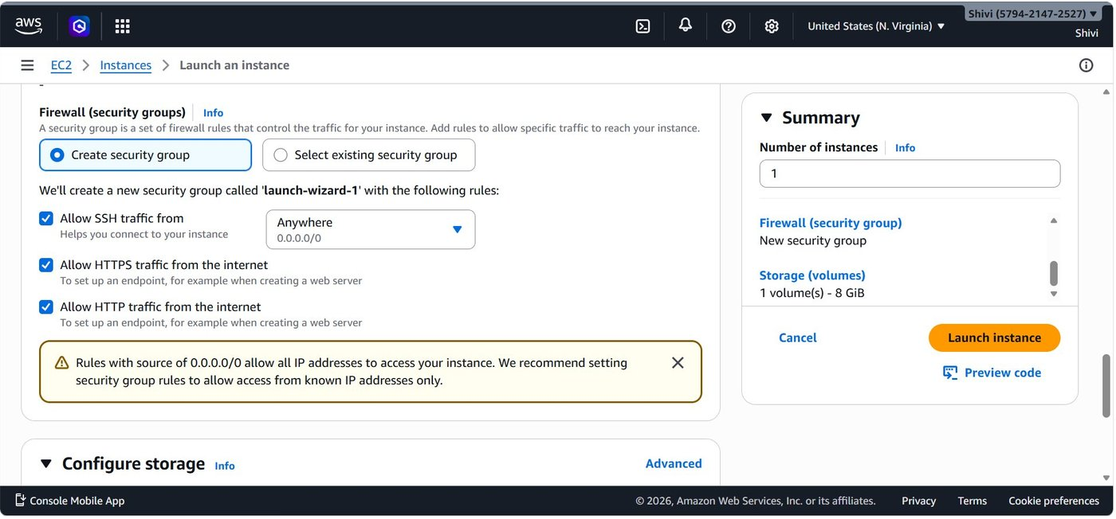

Step 6: Review Network Settings in Detail
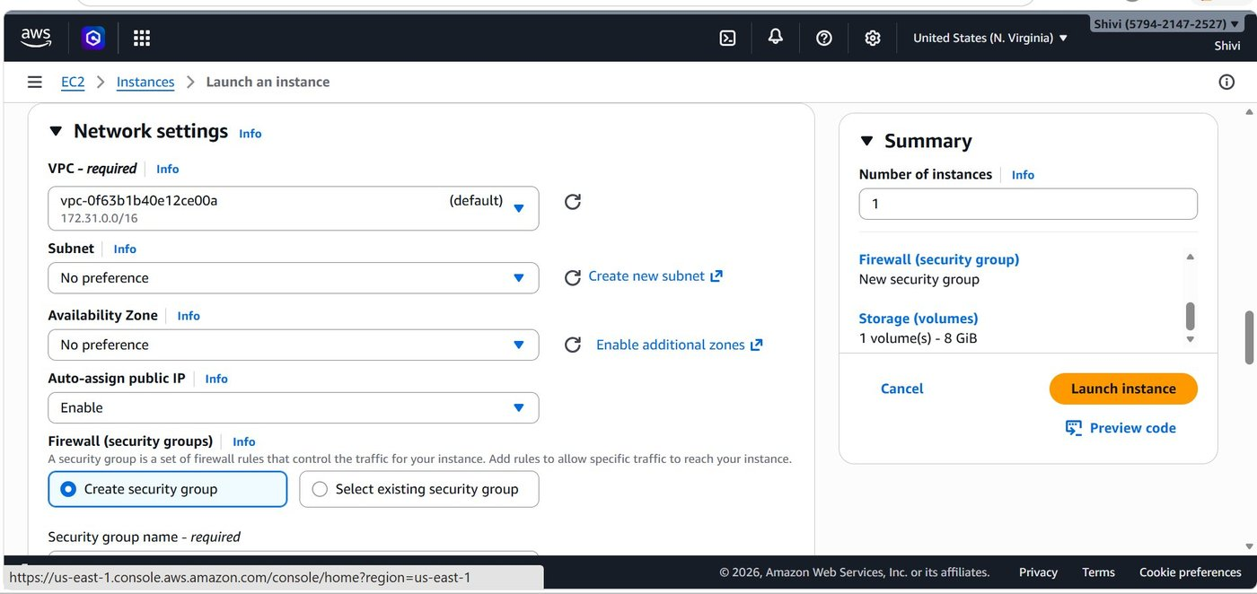

Step 7: Security Group Name & SSH Rule Detail
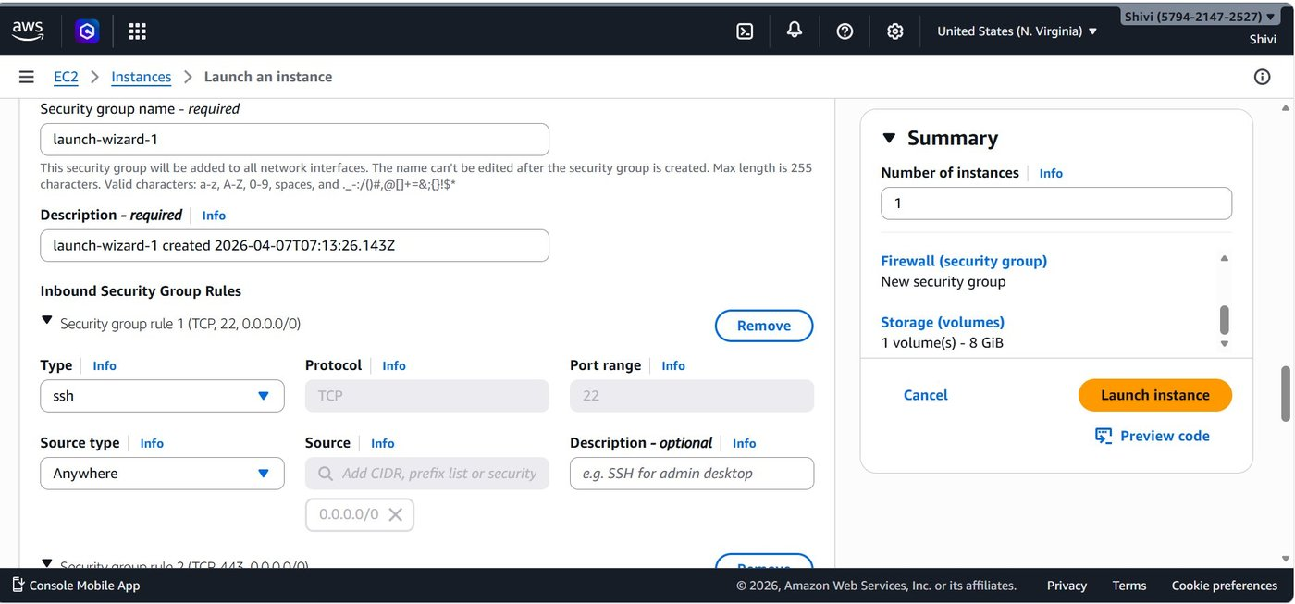

Step 8: HTTPS & HTTP Inbound Rules
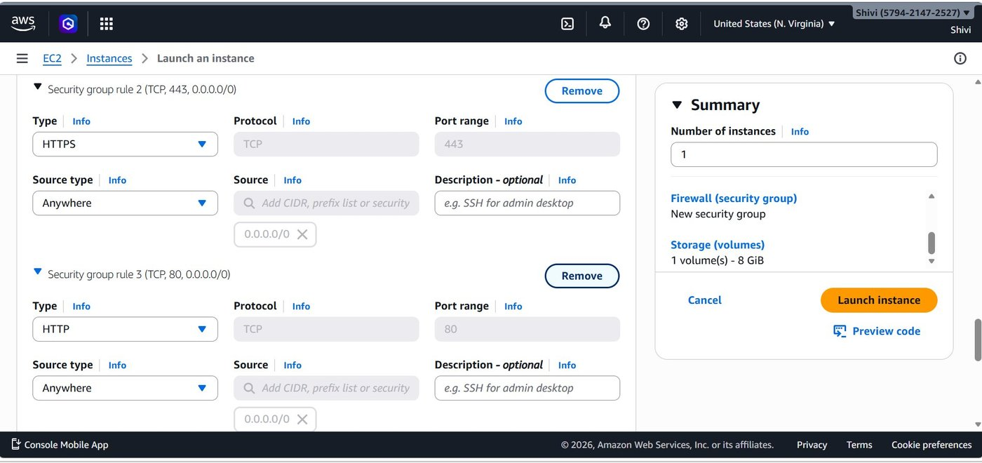

Step 9: Configure Storage
Set up the EBS volume that will be attached to your instance.
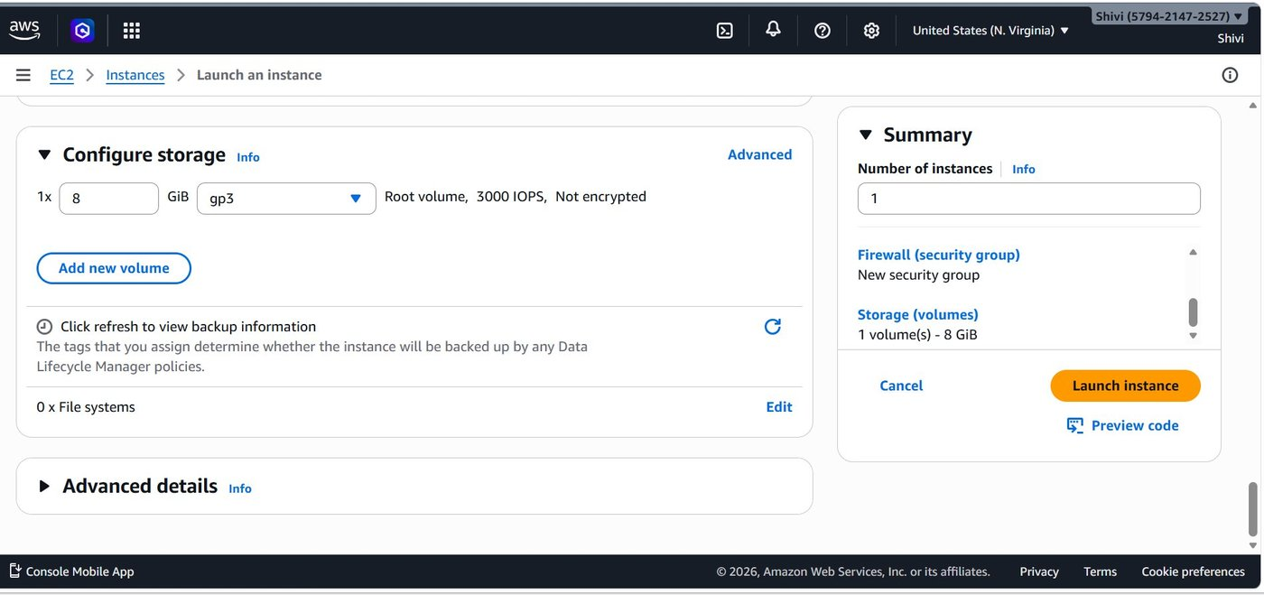

Step 10: Launch the Instance
Review the Summary panel on the right to confirm all settings, then click the orange "Launch instance" button. AWS will display a green success banner.
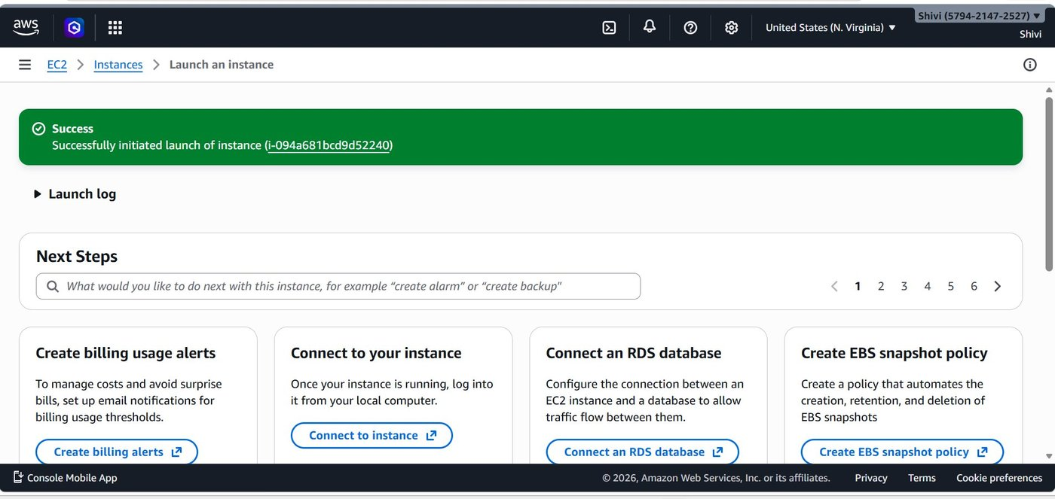

Step 11: Verify the Running Instance
Navigate to EC2 > Instances to confirm your instance is running and all health checks have passed.
- Name: shivi_2026 • Instance ID: i-094a681bcd9d52240
- Instance State: Running
- Status check: 3/3 checks passed
- Instance Type: t3.micro
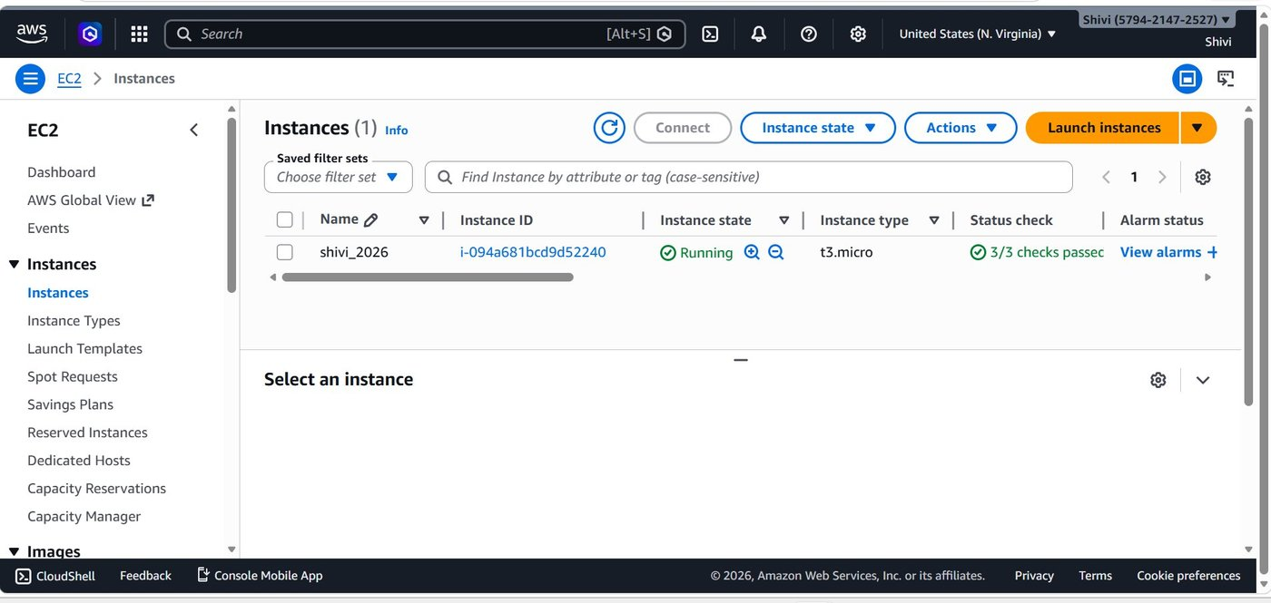

PART 2: Adding an EBS Volume

Step 12: Open the Create Volume Page
In the AWS Console, navigate to EC2 > Elastic Block Store > Volumes, then click "Create volume".

Volume Settings
- Volume type: General Purpose SSD (gp3)
- Size: 8 GiB
- IOPS: 3000
- Throughput: 125 MiB/s (gp3 baseline).
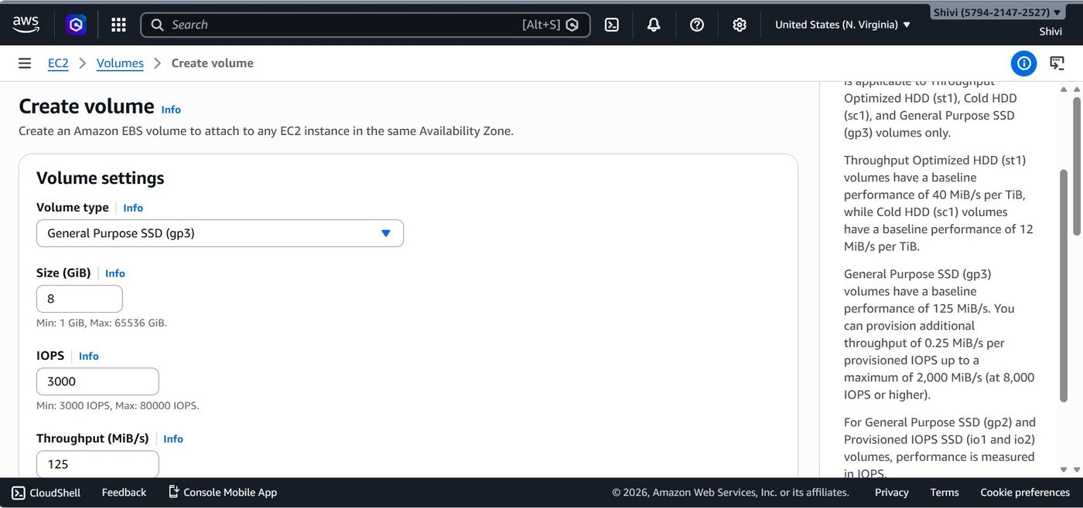

Step 13: Set Availability Zone, Snapshot & Encryption
Scroll down to configure the Availability Zone, Snapshot source, Encryption, and optional Tags.
- Availability Zone: use1-az1 (us-east-1a) — must match the target EC2 instance's zone.
- Snapshot ID:
- Encryption: Leave unchecked for this demo. Enable for production workloads.
- Tags (optional):
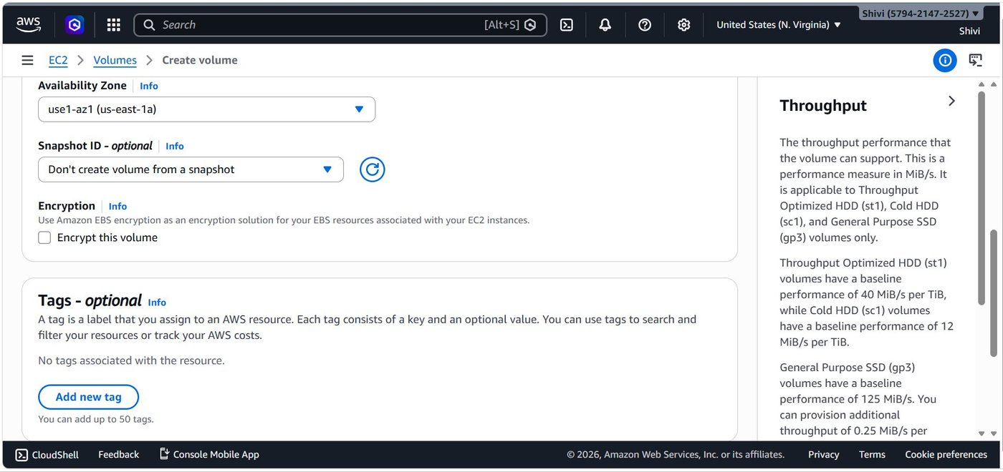

Step 14: Review Snapshot Summary & Create
At the bottom of the page, review the Snapshot summary panel and click "Create volume".
- Click the orange Create volume button to proceed.
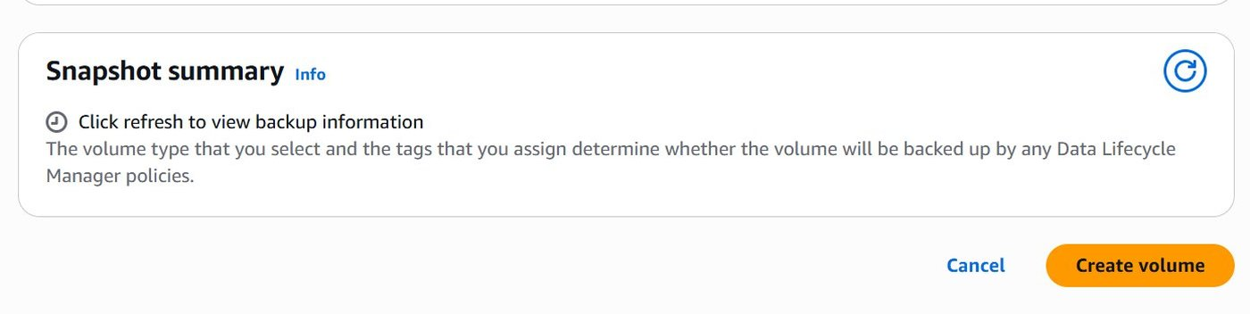

Step 15: Confirm Volume Created Successfully
AWS displays a green success banner and the new volume appears in the Volumes list.
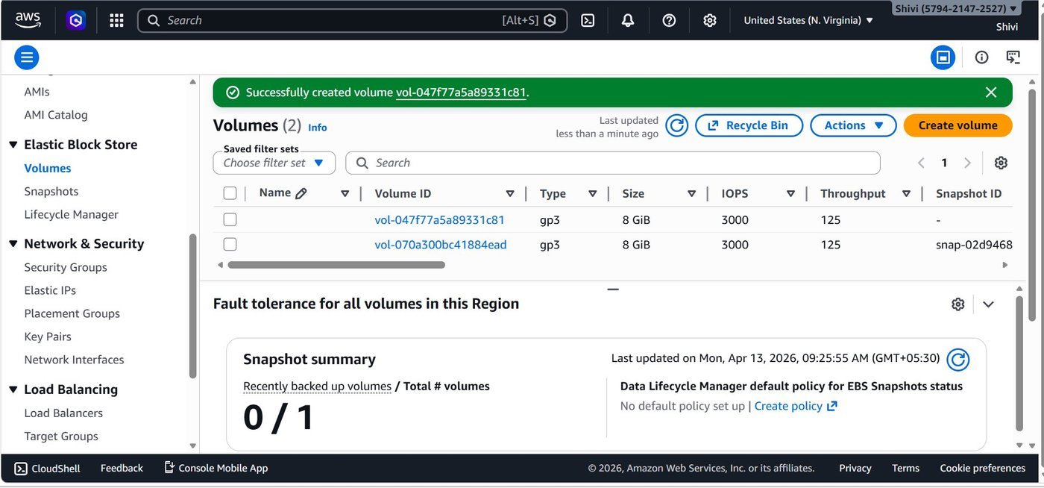

PART 3: Connecting to the Instance and Creating a Text File

Step 16: Open "Connect to Instance"
Navigate to EC2 > Instances, select your instance, and click "Connect". The Connect to instance page opens.
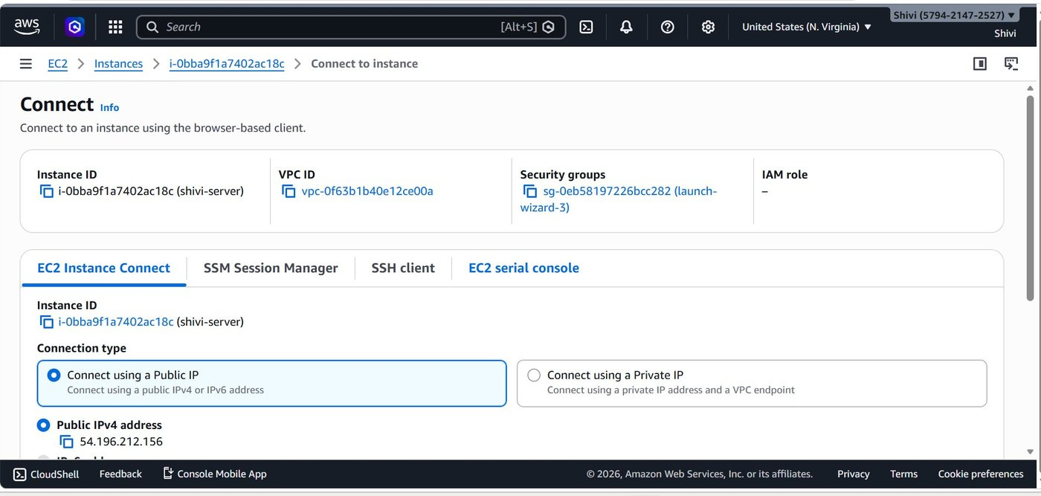

Step 17: Configure Connection Settings & Connect
On the EC2 Instance Connect tab, confirm the connection type, IP address, and username, then click Connect.
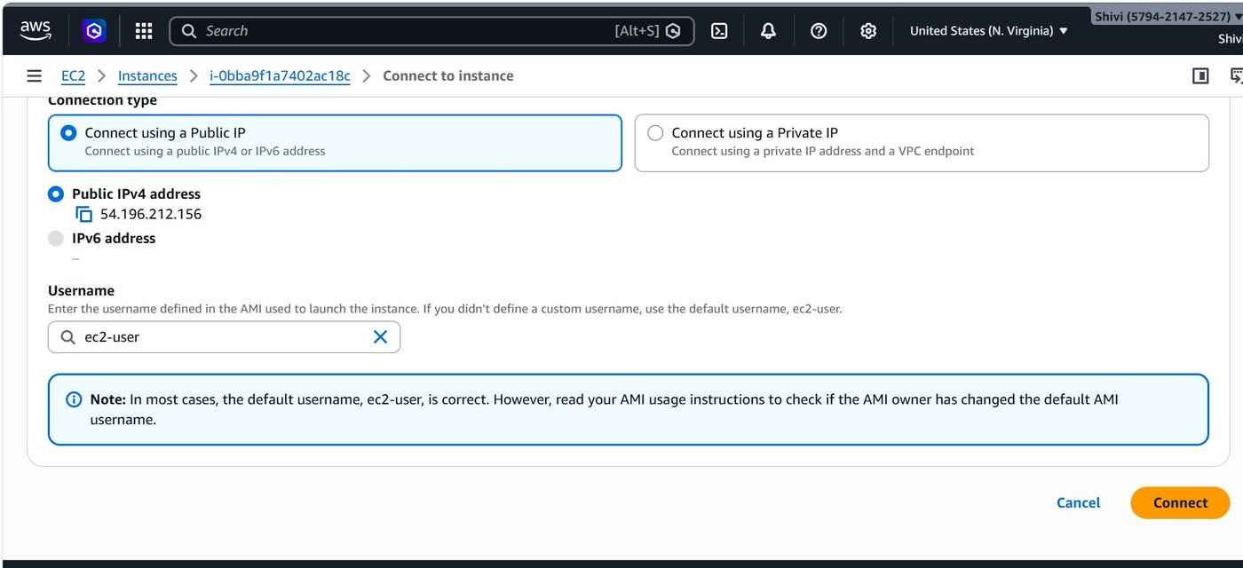

Step 18: Create a Directory and Text File in the Terminal
Once connected, the Amazon Linux 2023 terminal opens. Run the following commands to create a directory and write a text file inside it.

Commands Executed
1. Verify the current working directory:
pwd
2. Create a new directory named "nidhi":
mkdir nidhi
3. Navigate into the directory:
cd nidhi/
4. Create and edit a text file using vim:
vim hello.txt
5. Display the file contents:
cat hello.txt
6. Exit the terminal session:
exit
